**Application of vector algebra and physics in designing steering behaviours of autonomous agents for realistic display in 2 dimensions**

**Abstract**

In this article I want to focus on problematics of steering behaviours of autonomous characters in software and display methods. The importance of this topic hides in usability in animation, film effects and mainly in games. If we want the user to have the best realistic experience from movement of the objects possible, we have to obey specific rules of algebra and physics and also take their atributes into consideration.

**1 Introduction**

Development in animation and games forces the creators to make the games more and more realistic. One of the most important aspects of realistic perception of a game is the movement of objects and I want to present ideas for designing these objects and their steering behaviors. We will call the objects autonomous agents. Autonomous agent, speaking of games, is an arbitrary entity of software origin, which is able to make decisions based on assigned instructions and consecutive stimulus from the environment. These agents are not controlled by a player but they are important part of the game because their action can significantly influence the flow of the game.

**2 Autonomous agents**

**2.1 Definition of autonomous agents**

The autonomous agents generally refers to an entity that chooses its how to act in its environment without any influence from a global plan or a leader. For example a villain who runs away from police desires and decides on his own that he wants to escape and starts an action. There are three key components of autonomous agents we want to keep in mind.

* An autonomous agent has limited ability to perceive its environment. It makes sense that if autonomous agent has to decide on its action, it should be somehow aware of the environment it is located in. The question here is how much limited is the ability. If we wanted the object to be all-knowing creature aware of everything else around it, we need to give it an access to information about everything. On the other side if we wanted it to have just very narrow view of the environment, let’s say just a few pixels around it.
* An autonomous agent processes the information from its environment and calculates an action. The action is represented as a force that influences the object. For example a police officer sees a thief and is attracted to him. The attraction is represented by a force pointing towards his location.
* An autonomous agent should have no leader. This is not something that defines every autonomous agent. Sometimes you need to state some global rules that it has to follow, but mostly you want the object to decide on its own, calculate it’s own actions.

**2.2 Types of behaviors according to the number of objects involved**

Craig Raynolds in his paper introduces some types of behaviors that could appear talking about autonomous agents and how they behave. They divide into two main groups:

* Simple behavior for individuals and pairs
* Combined behaviors and groups

In this article I want to focus on the first mentioned.

**3 Problem statement**

**3.1 Braitenberg vehicle**

Braitenberg vehicle is an entity that is a hypothetical self operating machine that can make decisions about how to behave in an environment based on its sense perception. (odkaz na knihu Vehicles by Valentino Braitenberg).

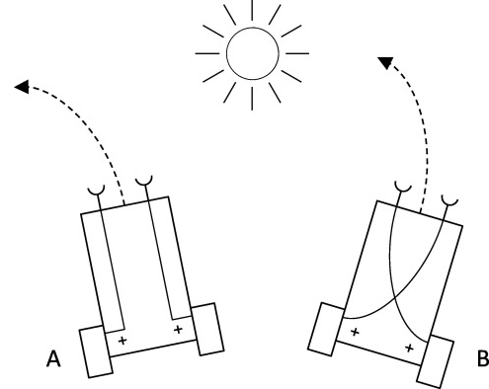

Object A steers away from the light source and object B steers towards the light source. It is not just about steering away or towards the sun. We could say that these vehicles feel emotion about the object. Vehicle A feels fear from the sun and vehicle B is attracted to it. I want the term vehicle in this article to be clear because in the paper when I mention vehicle I will be refering to the concept of Braitenberg vehicle and its characteristics.

**3.2 Problem to solve**

Let’s say we want to simulate a simple behavior for a pair (odkaz na 2.2). A vehicle (imagine a car) that wants to arrive to a specific position (f. e. parking lot). We could say that in the car there is a driver. He perceives the environment with his eyes and sees the location of the parking lot. Processes his distance from the place and calculates and action. He starts steering towards the parking lot. Notice the word steering here which is very important. We do not want to simulate a car that is immediately able to turn around and head towards the target in a maximum speed. We want the animation to be smooth and realistically looking. What rules do we have to follow if we want to simulate a situation like this?

**4 Seek – a pursuit of a static target**

**4.1 Simple vehicle model**

Craig Raynolds in his paper (on page 6) presents a simple vehicle model which I need to introduce to you. There are 6 atributes that our vehicle will have.

Simple Vehicle Model: mass scalar

position vector

velocity vector

max_force scalar

max_speed scalar

orientation N basis vectors

**4.2 Characteristics of seek**

Seeking steers a character towards a specified position in a space. This behavior alignes the vector of a velocity towards the target. But how do we calculate the steering force if we do not want the vehicle to steer immediately after seeing the target? We can diagram our problem from 3.2.

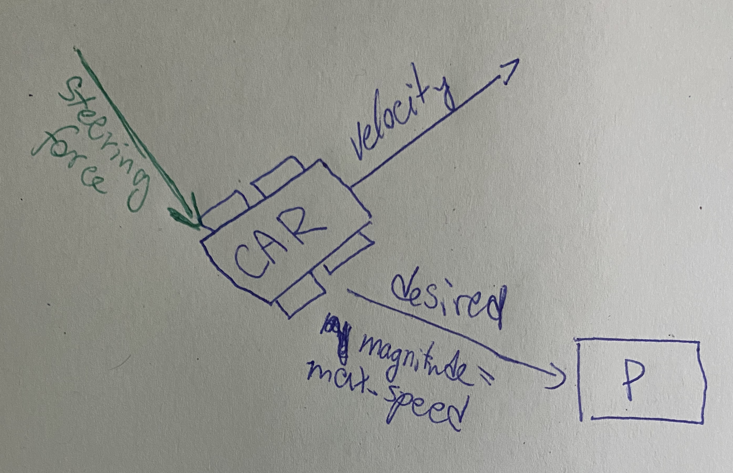 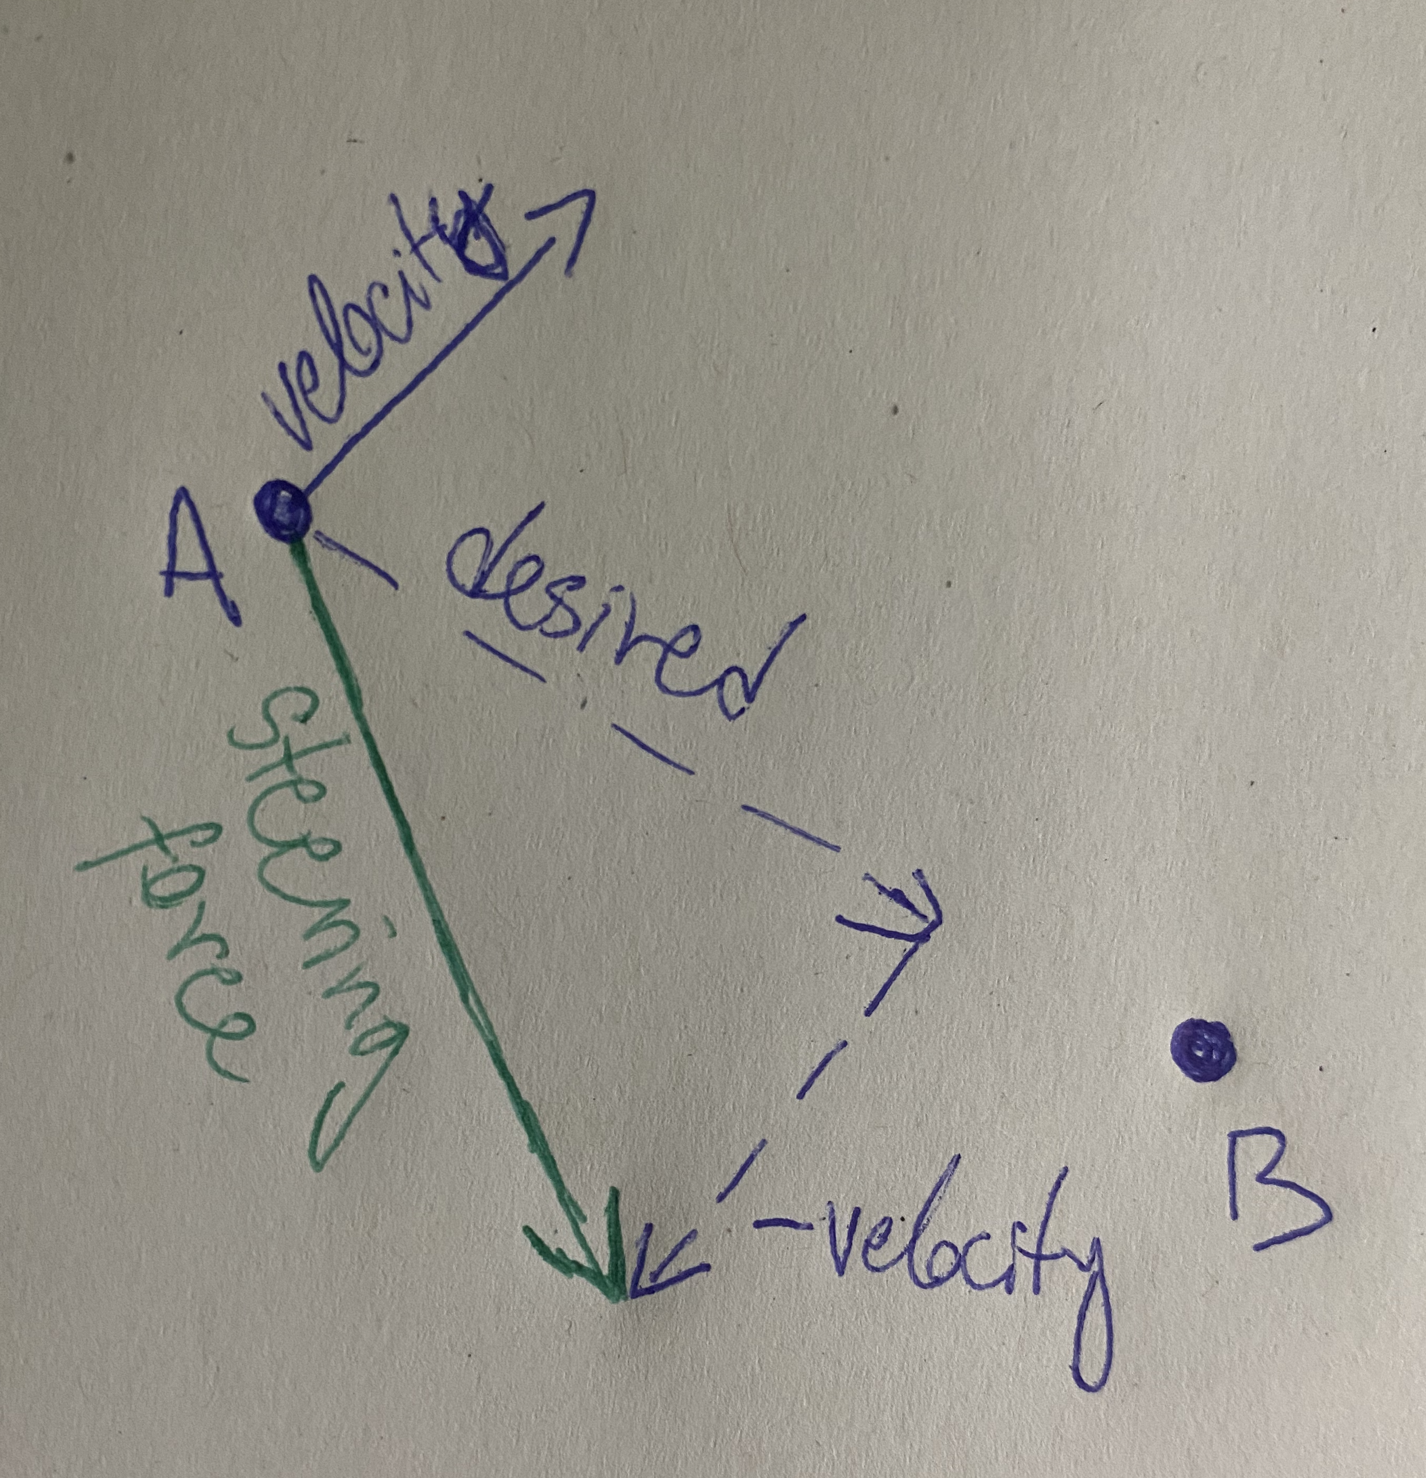

The steering force is then calculated with this espression as shown on the right diagram

Steering force= desired – velocity